**project design phase-II**

**Technology stack architecture and stack**

|  |  |
| --- | --- |
| Date | 06 November 2023 |
| Team ID | NM2023TMID08426 |
| Project Name | project design phase-IITechnology stack architecture and stack |
| Maximum Marks | 4 Marks |

**Technical Architecture:**

The Deliverable shall include the architectural diagram as below and the information as per the table1 & table 2

**Example: Order processing during pandemics for offline mode**

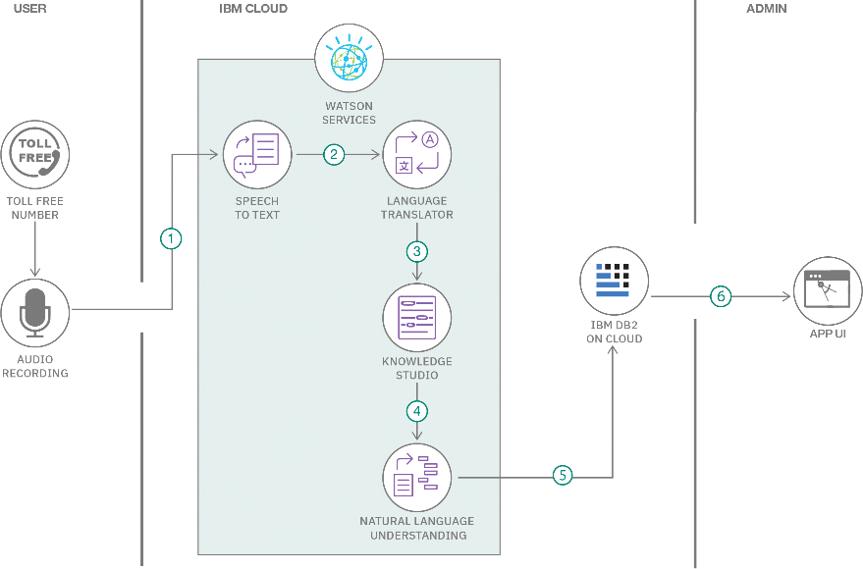**Guidelines:**

* **Include all the processes (As an application logic / Technology Block)**
* **Provide infrastructural demarcation (Local / Cloud)**
* **Indicate external interfaces (third party API’s etc.)**
* **Indicate Data Storage components / services**
* **Indicate interface to machine learning models (if applicable)**

**Table-1 : Components & Technologies:**

|  |  |  |  |
| --- | --- | --- | --- |
| **S.No** | **Component** | **Description** | **Technology** |
| 1. | User Interface | How user interacts with application e.g. Web UI, Mobile App, Chatbot etc. | HTML, CSS, JavaScript / Angular Js / React Js etc. |
| 2. | Application Logic-1 | Logic for a process in the application | Java / Python |
| 3. | Application Logic-2 | Logic for a process in the application | IBM Watson STT service |
| 4. | Application Logic-3 | Logic for a process in the application | IBM Watson Assistant |
| 5. | Database | Data Type, Configurations etc. | MySQL, NoSQL, etc. |
| 6. | Cloud Database | Database Service on Cloud | IBM DB2, IBM Cloudant etc. |
| 7. | File Storage | File storage requirements | IBM Block Storage or Other Storage Service or Local Filesystem |
| 8. | External API-1 | Purpose of External API used in the application | IBM Weather API, etc. |
| 9. | External API-2 | Purpose of External API used in the application | Aadhar API, etc. |
| 10. | Machine Learning Model | Purpose of Machine Learning Model | Object Recognition Model, etc. |
| 11. | Infrastructure (Server / Cloud) | Application Deployment on Local System / Cloud Local Server Configuration:  Cloud Server Configuration : | Local, Cloud Foundry, Kubernetes, etc. |

**Table-2: Application Characteristics:**

|  |  |  |  |
| --- | --- | --- | --- |
| **S.No** | **Characteristics** | **Description** | **Technology** |
| 1. | Open-Source Frameworks | List the open-source frameworks used | Technology of Opensource framework |
| 2. | Security Implementations | List all the security / access controls implemented, use of firewalls etc. | e.g. SHA-256, Encryptions, IAM Controls, OWASP etc. |
| 3. | Scalable Architecture | Justify the scalability of architecture (3 – tier, Micro-services) | Technology used |

|  |  |  |  |
| --- | --- | --- | --- |
| **S.No** | **Characteristics** | **Description** | **Technology** |
| 4. | Availability | Justify the availability of application (e.g. use of load balancers, distributed servers etc.) | Technology used |
| 5. | Performance | Design consideration for the performance of the application (number of requests per sec, use of  Cache, use of CDN’s) etc. | Technology used |

The aftereffects of the COVID-19 will affect everyone. The global economy will feel the impact of the reduction in liabilities, budgets, and investment portfolios. However, it was this crisis that showed us all once again the importance of switching to digital and mobile solutions.

During this crisis, whatever industry your business belongs to, remember the following:

* The first thing the consumer leaves behind is luxury goods (cars, yachts, real estate), complex goods (grain, metals, etc.), and new projects and startups.
* Second thing: various wants-not-needs, i.e. restaurant visits, clothes and home shopping, gym memberships, etc. Basically, everything that is not absolutely required for life, but can be categorized as “nice to have.” Even when grocery shopping, people are starting to stock up on non-perishables and avoid extra expenses.
* Third: education
* Finally, the last thing people will consider refusing medicine.